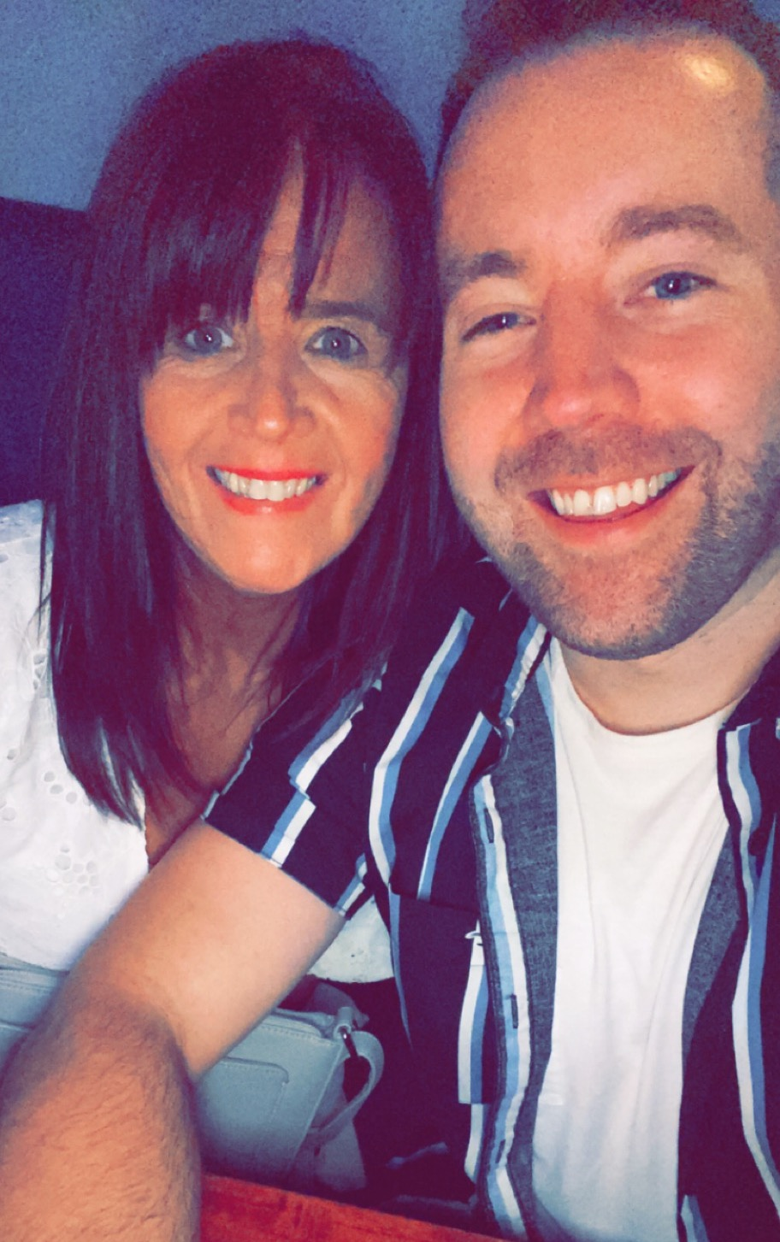
100 YEARS
Choreographed by Maggie Gallagher & Gary O’Reilly (December 2021)
64 Count 2 Wall Intermediate Level Linedance
Music: 100 Years by Hedegaard & Echosmith & Tvilling (3:29) (Amazon & iTunes)
Intro: 16 counts

S1: WALK, WALK, ANCHOR STEP, BACK, BACK, ¼ SIDE ROCK
1-2 Walk forward on right, Walk forward on left
3&4 Lock right behind left, Step weight onto left, Step slightly back on right
5-6 Walk back on left, Walk back on right
7-8 ¼ left rocking left to left side, Recover on right [9:00]

S2: L SAILOR, BEHIND, SWEEP, BEHIND, SIDE, CROSS SHUFFLE
1&2 Cross left behind right, Step right to right side, Step left to left side
3-4 Cross right behind left, Ronde sweep left from front to back
5-6 Cross left behind right, Step right to right side
7&8 Cross left over right, Step right to right side, Cross left over right

S3: SIDE ROCK, ¼ COASTER, ROCK, RECOVER, ½ SHUFFLE
1-2 Rock right to right side, Recover on left
3&4 ¼ right stepping right behind left, Step left next to right, Step forward on right [12:00]
5-6 Rock forward on left, Recover on right
7&8 ¼ left stepping left to left side, Step right next to left, ¼ left stepping forward on left [6:00]

S4: ¼ SIDE, DRAG, BEHIND SIDE CROSS, POINT, CROSS, POINT, CROSS
1-2 ¼ left taking long step on right to right side, Drag left to meet right [3:00]
3&4 Cross left behind right, Step right to right side, Cross left over right
5-6 Point right to right side, Cross right slightly over left
7-8 Point left to left side, Cross left slightly over right

S5: ROCK, RECOVER, ½ SHUFFLE, ½ SHUFFLE, BACK ROCK, RECOVER
1-2 Rock forward on right, Recover on left
3&4 ¼ right stepping right to right side, Step left next to right, ¼ right stepping forward on right [9:00]
5&6 ¼ right stepping left to left side, Step right next to left, ¼ right stepping back on left [3:00]
7-8 Rock back on right, Recover on left

S6: WALK, HOLD, BALL STEP, TOUCH, WALK, HOLD, BALL STEP, HITCH
1-2 Walk forward on right to right diagonal, HOLD [4:30]
&3-4 Step on ball of left next to right, Step forward on right, Touch left next to right [4:30]
5-6 Walk forward on left to left diagonal, HOLD [1:30]
&7-8 Step on ball of right next to left, Step forward on left, Ronde hitch right across left [1:30]

S7: CROSS, BACK, ¼ CHASSE, CROSS/DIP, SIDE, BEHIND, SIDE
1-2 Cross right over left, ⅛ right stepping back on left [3:00]
3&4 ¼ right stepping right to right side, Step left next to right, Step right to right side [6:00]
5-6 Cross left over right bending knees, Step right to right side
7-8 Cross left behind right, Step right to right side

S8: CROSS ROCK, L CHASSE, R JAZZ BOX
1-2 Cross rock left over right, Recover on right
3&4 Step left to left side, Step right next to left, Step left to left side
5-6 Cross right over left, Step back on left
7-8 Step right to right side, Step forward on left

TAG : At the end of Wall 2, dance the 8 count Tag facing [12:00]:
ROCKING CHAIR, STEP, ½ PIVOT, STEP, ½ PIVOT
1-2-3-4 Rock forward on right, Recover on left, Rock back on right, Recover on left
5-6-7-8 Step forward on right, ½ pivot left, Step forward on right, ½ pivot left [12:00]

ENDING: Dance 31 counts of Wall 7. On count 32, turn ¼ left stepping down on left, to finish facing [12:00]

Contact: Gary O’Reilly - oreillygaryone@gmail.com - 00353857819808
https://www.facebook.com/gary.reilly.104 - www.thelifeoreillydance.com
Maggie Gallagher - +44 7950291350
www.facebook.com/maggiegchoreographer - www.maggieg.co.uk

