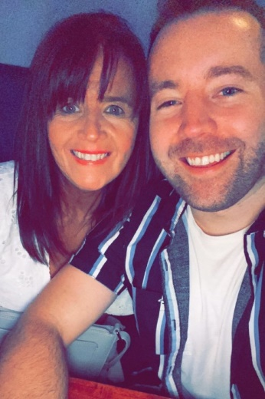
ALL FOR YOU
Choreographed by Maggie Gallagher (UK) & Gary O’Reilly (IRE) November 2022
96 Count 2 Wall Intermediate Level Linedance
Music: All For You by Cian Ducrot & Ella Henderson (iTunes & Amazon)
Intro: 24 counts (9 secs)

S1: WALK, HOLD, BACK, BACK, TOGETHER
1-2-3 Walk forward on left towards [1:30], HOLD (2-3)
4-5-6 Step back on right, Step back on left, Step right next to left [1:30]

S2: WALK, RONDE HITCH, STEP, HITCH BEHIND, HOLD
1-2-3 Walk forward on left, ⅛ left ronde hitching right over left (2-3) [12:00]
4-5-6 Step forward on right towards [10:30], Hitch left knee hooking left toe behind right, HOLD

S3: BACK, RONDE HITCH, BEHIND, SIDE ROCK
1-2-3 Step back on left, Ronde hitch right from front to back straightening to [12:00] (2-3)
4-5-6 Cross right behind left, Rock left to left side, Recover on right

S4: BEHIND, RONDE SWEEP, BEHIND, SIDE, CROSS
1-2-3 Cross left behind right, Ronde sweep right from front to back (2-3)
4-5-6 Cross right behind left, Step left to left side, Cross right over left
*Restart Walls 2 & 5 with step change

S5: SIDE, DRAG, FORWARD, DRAG
1-2-3 Long step left to left side, Drag right to meet left (2-3)
4-5-6 Long step forward on right to right diagonal, Drag left to meet right (5-6) [1:30]

S6: ¼ DIAMOND SHAPE WITH BALANCE STEPS
1-2-3 Step forward on left to [1:30], Step right next to left straightening to [12:00], ⅛ left stepping left in place [10:30]
4-5-6 Step back on right, ⅛ left stepping left to left side, Step right next to left [9:00]

S7: STEP, POINT, HOLD, BACK, POINT, HOLD
1-2-3 Step forward on left, Point right to right side and slightly forward, HOLD
4-5-6 Step back on right, Point left to left side and slightly back, HOLD

S8: CROSS, ¼ RONDE SWEEP, R TWINKLE
1-2-3 Cross left over right, ¼ left ronde sweeping right from back to front (2-3) [6:00]
4-5-6 Cross right over left, Step left to left side, Step right to right side towards [7:30]

S9: FORWARD BALANCE STEP, BACK BALANCE STEP
1-2-3 Step forward on left, Step right next to left, Step left in place [7:30]
4-5-6 Step back on right, ⅛ left stepping left next to right, Step right in place [6:00]

S10: FORWARD BALANCE STEP, BACK, BACK, BACK
1-2-3 Step forward on left to [4:30], Step right next to left, Step left in place [4:30]
4-5-6 Step back on right, Step back on left, Step back on right [4:30]

S11: BACK, HOOK, HOLD, STEP, ½, BACK
1-2-3 Step back on left, Hook right across left, HOLD
4-5-6 Walk forward on right, ½ right stepping back on left, Step back on right [10:30]

S12: BACK, HOOK, HOLD, WALK, ⅛ RONDE SWEEP
1-2-3 Step back on left, Hook right across left, HOLD [10:30]
4-5-6 Walk forward on right, ⅛ right ronde sweeping left from back to front (5-6) [12:00]

S13: L TWINKLE, R TWINKLE
1-2-3 Cross left over right, Step right to right side, Step left to left side
4-5-6 Cross right over left, Step left to left side, Step right to right side
Choreographers’ note: Move slightly forward on the twinkle steps

S14: STEP, KICK, BACK, ½, WALK
1-2-3 Step forward on left, Hitch right knee and slow kick right forward with right toe pointed (2-3)
4-5-6 Step back on right, ½ left stepping forward on left, Walk forward on right [6:00]

S15: STEP, HITCH, BACK, SIDE ROCK
1-2-3 Step forward on left, Slow hitch right knee forward (2-3)
    - Step back on right, Rock left to left side, Recover on right

S16: BEHIND, RONDE SWEEP, R SAILOR
1-2-3 Step left behind right, Ronde sweep right from front to back (2-3)
4-5-6 Step right behind left, Step left to left side, Step right to right side angling body to [7:30]

*RESTARTS: During Walls 2 & 5 both facing [6:00].
Dance 21 counts then replace counts 4-5-6 with a R Sailor Step. Restart the dance from the beginning.

ENDING: The dance finishes at the end of Wall 7. Cross left over right and unwind ½ right to finish facing [12:00]

Contact:
Gary O’Reilly:
oreillygaryone@gmail.com (+353)857819808
https://www.facebook.com/gary.reilly.104 www.thelifeoreillydance.com

Maggie Gallagher
www.facebook.com/MaggieGChoreographer
www.maggieg.co.uk

