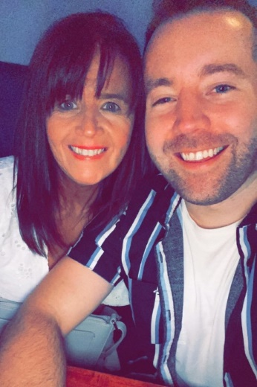
ANOTHER HEART
Choreographed by Maggie Gallagher & Gary O’Reilly (July 2022)
64 Count 2 Wall Low Advanced Level Linedance
Music: Another Heart by Ilira (2:22) (Amazon & iTunes)
Intro: 16 counts

S1: WALK BACK, ROCK BACK, RECOVER, R LOCK STEP, PRESS, RECOVER
1-2 Walk back on left, Rock back on right pushing hips back and popping left knee
3 Recover forward on left
4&5 Step forward on right, Lock left behind right, Step forward on right
6-7 Press forward on left, Recover back on right

S2: COASTER CROSS, HOLD, & TOGETHER, CROSS, SWAY, SWAY, TOGETHER
8&1 Step back on left, Step right next to left, Cross left over right
2 HOLD
&3-4 Small jump on right to right side, ⅛ left stepping left next to right, Cross right over left [10:30]
5-6-7 Sway left rolling hips left and straightening to [12:00], Sway right rolling hips right, Step left next to right

S3: OUT OUT IN CROSS, HOLD, & BACK, BACK, ROCK BACK, RECOVER, WALK, SWEEP
&8&1 Step out and up on ball of right, Step out and up on ball of left, Step down on right in centre, Cross left over right
2 HOLD
&3-4 Small jump back on right, Step back on left popping right knee, Step back on right popping left knee
5-6 Rock back on left pushing hips back, Recover on right pushing hips forward
7-8 Walk forward on left, Ronde sweep right from back to front

S4: CROSS, ¼, ¼, ¼, CHUG STEPS x3
1-2 Cross right over left, ¼ hinge turn right stepping back on left [3:00]
3-4 ¼ hinge turn right stepping right to right side, ¼ hinge turn right stepping left to left side [9:00]
5-6 Small hop forward on right popping left knee next to right, Small hop forward on left popping right knee next to left
7 Small hop forward on right popping left knee next to right

S5: CHASSE L, HOLD, & SIDE, TOUCH, R ROLLING VINE
8&1 Step left to left side, Step right next to left, Step left to left side
2 HOLD
&3-4 Step right next to left, Step left to left side, Touch right next to left bending right knee slightly across left
5-6 ¼ right stepping forward on right, ½ right stepping back on left [6:00]
7 ¼ right stepping right to right side angling body to [10:30]

S6: L LOCK STEP, HOLD, & ROCK, RECOVER, BACK, ½, WALK
8&1 Step forward on left to [10:30], Lock right behind left, Step forward on left
2 HOLD
&3-4 Step right next to left, Rock forward on left rolling hips forward, Recover on right
5-6-7 Step back on left, ½ right stepping forward on right, Walk forward on left [4:30]

S7: R LOCK STEP, HOLD, & ROCK, RECOVER, BACK, TOUCH, BACK, TOUCH
8&1 Step forward on right to [4:30], Lock left behind right, Step forward on right
2 HOLD
&3-4 Step left next to right, Rock forward on right rolling hips forward, Recover on left
5-6 ⅛ right stepping back on right rolling right shoulder back, Touch left next to right dipping into right hip [6:00]
7-8 Step back on left rolling left shoulder back, Touch right next to left dipping into left hip

S8: ¼ ROCK, ¼ RECOVER, ½, ½, WALK, WALK, ANCHOR STEP
1-2 Rock ¼ right pushing hips to right [9:00], ¼ left recovering weight forward on left [6:00]
3-4 ½ left stepping back on right, ½ left stepping forward on left [6:00]
5-6 Walk forward on right, Walk forward on left
7&8 Lock right behind left, Step weight onto left, Step slightly back on right

TAG : At the end of Wall 2, dance the 16 count Tag facing [12:00]:
SIDE, DRAG, & SIDE, POINT, ¼, ½, ¼, TOUCH (REPEAT)
1-2 Long step on left to left side, Drag right to meet left
&3-4 Step down on right next to left, Step left to left side, Point right to right side angling body to [10:30]
5-6 ¼ right stepping forward on right, ½ right stepping back on left
7-8 ¼ right stepping right to right side, Touch left next to right [12:00]
9-16 REPEAT counts 1-8

ENDING: At the end of Wall 4, stomp left to left side to finish the dance [12:00]

Thank you to Margaret Hains for suggesting this track

Contact: Gary O’Reilly - oreillygaryone@gmail.com - 00353857819808
https://www.facebook.com/gary.reilly.104 - www.thelifeoreillydance.com
Maggie Gallagher - +44 7950291350
www.facebook.com/maggiegchoreographer - www.maggieg.co.uk

