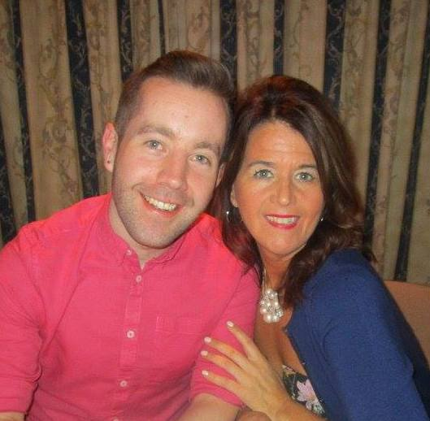

CHANTAJE
Choreographed by Gary O’Reilly & Maggie Gallagher (November 2016)
32 Count 4 Wall Intermediate Line Dance
Music: Chantaje by Shakira feat. Maluma (Available from iTunes)
Intro: 16 counts

S1: R CROSS ROCK, R SIDE, CROSS ROCK, SIDE ROCK, CROSS, SIDE ROCK, CROSS, SIDE, BEHIND, ¼
1-2& Cross rock right over left, Recover on left, Step right to right side
3&4& Cross rock left over right, Recover on right, Rock left to left side, Recover on right
5-6& Cross left over right, Rock right to right side, Recover on left
7&8& Cross right over left, Step left to left side, Cross right behind left, ¼ left stepping forward on left [9:00]

S2: FORWARD, PIVOT ½ L, ¼ L, BACK ROCK, SIDE TOUCH, SIDE TOUCH, BACK, BACK TOGETHER
1-2-3 Step forward on right, Pivot ½ left, ¼ turn left stepping right to right side [12:00]
4& Rock back on left, Recover on right
5&6& Step left to left side, Touch right next to left, Step right to right side, Touch left next to right
7-8& Walk back on left pushing hips back, Step back on right, Step left next to right * Tag/Restart wall 5

S3: R DOROTHY, ¼ L DOROTHY, STEP ½ PIVOT L, BALL ¼, BALL ¼, BALL ½
1-2& Step forward on right, Lock left behind right, Step forward on right
3-4& ¼ left stepping forward on left, Lock right behind left, Step forward on left [9:00]
5-6 Step forward on right, Pivot ½ left (weight on left) [3:00]
&7 Step on ball of right next to left, ¼ left stepping forward on left
&8& Step on ball of right next to left, ¼ left stepping forward on left, Step on ball of right next to left
1 ½ left stepping forward on left [3:00]

S4: SWEEP CROSS, BACK SIDE CROSS, & TOUCH, BUMP, SIDE ROCK CROSS &
2 Ronde sweep right from back to front crossing right over left
3&4 Step back on left, Step right to right side, Cross left over right
&5-6 Step on ball of right to right side, Touch left next to right, Step left to left side bumping hip left
7&8& Rock right to right side, Recover on left, Cross right over left, Step left to left side

* Tag/Restart during wall 5, facing [12:00]
After the first 16 counts of Wall 5 add:

Tag: WALK R, WALK L
1-2 Walk forward on right, Walk forward on left

then restart from the beginning of the dance

Choreographed during the “Club Dance Holidays” week in Cyprus November 2016 and dedicated to everyone who attended the event.

YouTube Demo Video Link: https://www.youtube.com/watch?v=UtsfoSN3eSA

Contact: Gary O’Reilly @ oreillygary1@eircom.net or Maggie Gallagher @ www.maggieg.co.uk

