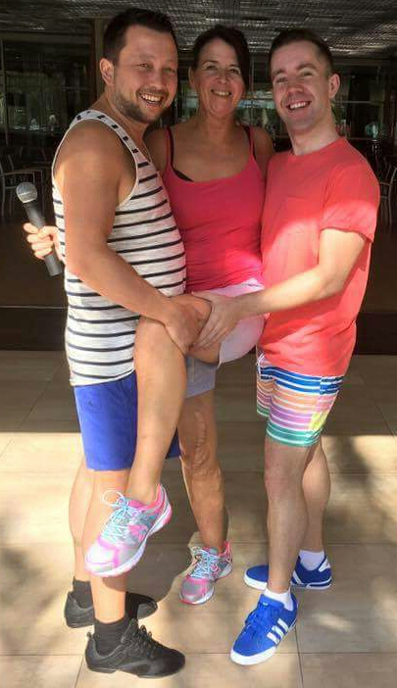
Corazon Diamante (Diamond Heart)
Choreographed by Roy Verdonk (NL), Maggie Gallagher (UK) & Gary O'Reilly (IR) (April 2016)
48 Count 2 Wall Intermediate Level Linedance
Music: Duele El Corazon (feat. Wisin) by Enrique Iglesias (available from iTunes or amazon 99p)
Intro: 16 counts (10 secs)
S1: R Side, Rock Back, L Side, Rock Back, R Side, L Sailor ¼ L, Ball ¼ Ball ¼
1-2& Step right to right side, Rock back on left, Recover on right
3-4& Step left to left side, Rock back on right, Recover on left
5 Step right to right side
6&7 Cross left behind right, ¼ turn left stepping right to right side, Step forward left [9:00]
&8& Step on ball of right next to left, ¼ turn left stepping forward on left [6:00], Step on ball of right next to left
1 ¼ left walking forward on left [3:00]

S2: R Mambo Fwd, L Coaster Cross & Cross, Rock & Cross Side Drag R
2&3 Rock forward on right, Recover on left, Step back on right
4&5 Step back on left, Step right next to left, Cross left over right
&6 Step right to right side, Cross left over right
&7&8 Rock right to right side, Recover on left, Cross right over left, Step left long step to left side dragging right to left

S3: Behind, Side Rock, Behind, Side Rock, Syncopated Sailor Steps ¼ R & Touch R
1-2& Step back on right slightly behind left, Rock left to left side, Recover on right
3-4& Step back on left slightly behind right, Rock right to right side, Recover on left
5&6 Cross right behind left, Step left to left side, Step right to right side
&7&8 Cross left behind right, ¼ turn right stepping forward on right [6:00], Step left to left side, Touch right next to left

S4: Bump, Bump, Bump Bump Bump, Walk, ½ Diamond R
1-2 Step back on right bumping hips back on right, Bump hips forward on left
3&4 Bump hips back on right, Bump hips forward on left, Bump hips back on right
5 Walk forward on left
6&7 Cross right over left, Step left to left side, ⅛ turn right stepping back on right [7:30]
8&1 Step back on left, ⅜ turn right stepping forward on right [12:00], Step forward on left

S5: Kick, Together, Side Rock, Kick, Together, Rock Recover Together, Rock Recover Together
2&3& Kick right forward rising slightly on ball of left, Step right next to left slightly forward, Rock left to left side, Recover on right
4& Kick left forward rising slightly on ball of right, Step left next to right
5-6& Rock and press forward on right, Recover on left, Step right next to left
7-8& Rock and press forward on left, Recover on right, Step left next to right

S6: ½ Diamond R, R Mambo Fwd, L Coaster Cross
1&2 Cross right over left, Step left to left side, ⅛ turn right stepping back on right [1:30]
3&4 Step back on left, ⅜ turn right stepping forward on right [6:00], Step forward on left * Restart Wall 1 & 3
5&6 Rock forward on right, Recover on left, Step back on right
7&8 Step back on left, Step right next to left, Cross left over right

Restart: Wall 1 & 3 after 44 counts facing 6:00

Released in Calpe on the Maggie G Club Dance holiday and dedicated to all the dancers who joined us.

Demo: https://www.youtube.com/watch?v=9ovjPOMd25s

Walkthrough: https://www.youtube.com/watch?v=grCwBYPsqXs

Contact: oreillygary1@eircom.net or www.maggieg.co.uk

