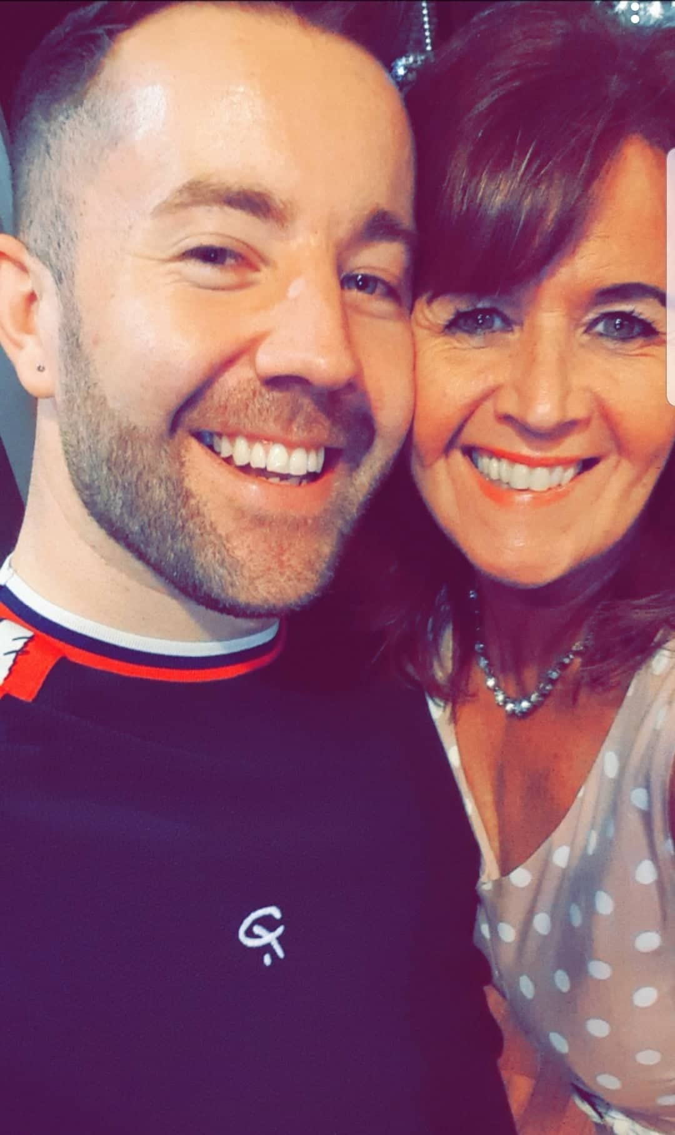
DARE TO LOVE
Choreographed by Gary O’Reilly & Maggie Gallagher (April 2020)
64 Count, 2 Wall, Intermediate Line Dance
Choreographed to: “I Dare You” by Kelly Clarkson
16 count intro
Thank you so much to Phil & Caroline Dewsbury from Newbury for suggesting this great track.

Section 1: STEP, LOCK, STEP, STEP LOCK STEP, STEP, PIVOT ½, WALK
1 2 3 Step forward on L (1), lock R behind L (2), step forward on L (3)
4 & 5 Step forward on R (4), lock L behind R (&), step forward on R (5)
6 7 8 Step forward on L (6), pivot ½ R (7), walk forward on L (8) (6:00)

Section 2: ½, ½, STEP, PIVOT ¼, CROSS, SWAY, SWAY, SWAY &
1 2 ½ L stepping back on R (1), ½ L stepping forward on L (2) (6:00)
3 4 Step forward on R (3), pivot ¼ L (4) (3:00)
5 6 Cross R over L (5), step L to L side rolling hips to L (6)
7 8 & Roll hips to R (7), roll hips to L (8), step R next to L (&)

Section 3: CROSS, SIDE, BACK, FWD ANCHOR STEP, ⅜, BACK, CROSS BALL
1 2 3 Cross L over R (1), step R to R side (2), ⅛ L stepping back on L popping R knee (3) (1:30)
4 & 5 Step R slightly over L (4), step weight back on L (&), step forward on R (5)
6 7 ⅜ R stepping back on L (6), step back on R (7) (6:00)
8 & Cross L over R (8), step on ball of R behind L (&)

Section 4: WALK, SWEEP, WALK, SWEEP, CROSS, SIDE ROCK, RECOVER, CROSS
1 2 Walk forward on L (1), ronde sweep R from back to front (2)
3 4 Walk forward on R (3), ronde sweep L from back to front (4)
5 6 Cross L over R (5), rock R out to R side pushing hip out (6)
7 8 Recover on L (7), cross R over L (8)

Section 5: SIDE, BACK ROCK, RECOVER, CHASSSE ¼, STEP, PIVOT ½, ½
1 2 3 Step L to L side (1), cross rock R behind L popping L knee (2), recover on L (3)
4 & 5 Step R to R side (4), step L next to L (&), ¼ R stepping forward on R (5) (9:00)
6 7 8 Step forward on L (6), pivot ½ R (7), ½ R stepping back on L (8) (9:00)

Section 6: BACK, SWEEP, BACK, SWEEP, ROCK BACK, RECOVER, WALK, ¼ POINT
1 2 Walk back on R behind L (1), ronde sweep L from front to back (2)
3 4 Walk back on L behind R (3), ronde sweep R from front to back (4)
5 6 Rock back on R (5), recover on L (6)
7 8 Step forward on R (7), ¼ R on ball of R pointing L to L side (8) (12:00)

Section 7: CROSS, POINT, ½ MONTEREY, POINT & POINT, TOUCH, KICK & TOUCH
1 2 3 Cross L over R (1), point R to R side (2), ½ R stepping R next to L (3) (6:00)
4 & 5 Point L to L side (4), step L next to R (&), point R to R side (5)
6 Touch R next to L (6)
7 & 8 Kick R forward (7), step slightly back on R (&) touch L next to R (8) *Restart Wall 5

Section 8: WALK, WALK, FORWARD COASTER, BACK, BACK, COASTER STEP
1 2 Walk forward on L (1), walk forward on R (2)
3 & 4 Step forward on L (3), step R next to L (&), step back on L (4)
5 6 Walk back on R (5), walk back on L (6)
7 & 8 Step back on R (7), step L next to R (&), step forward on R (8)

TAG: At the end of Wall 2, repeat the last 8 counts of the dance (Section 8) facing (12:00)

*RESTART: Wall 5 after 56 counts (drop the last 8 counts of the dance) facing (6:00)

ENDING: Dance 16 counts of Wall 7, then ¼ L stepping forward on left, ronde sweep R from back to front & cross R over L to finish facing (12:00)

Contact: Gary O’Reilly - oreillygaryone@gmail.com - 00353857819808
https://www.facebook.com/gary.reilly.104 - www.thelifeoreillydance.com
Maggie Gallagher - www.facebook.com/maggiegchoreographer - www.maggieg.co.uk

