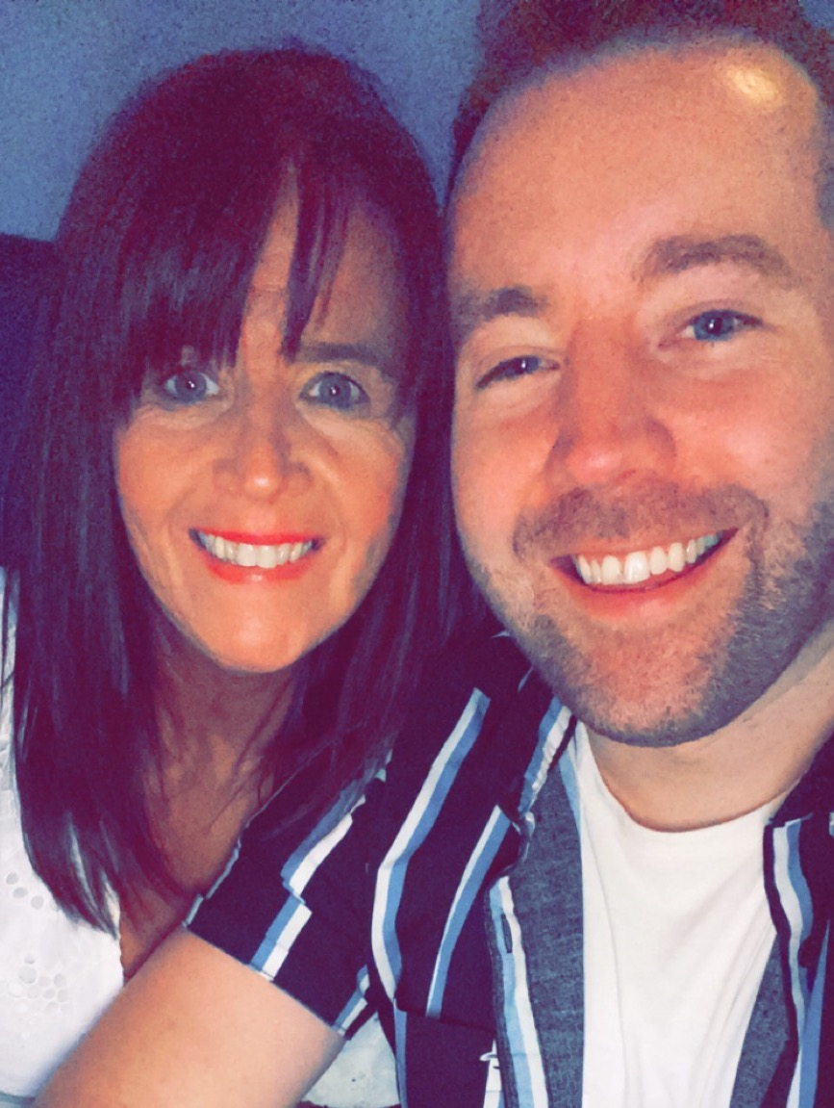
Easy On Me
Choreographed by Gary O’Reilly & Maggie Gallagher (October 2021)
48 Count, 2 Wall, Intermediate/Advanced level line dance.
Choreographed to: “Easy On Me” by Adele (3m45s)
Available from iTunes & Amazon
16 count intro

Section 1: WALK/SWEEP, FORWARD TOUCH BACK/SWEEP, BEHIND SIDE, CROSS ROCK & SPIRAL, RUN, RUN, RUN
1 Walk forward on R slightly across L sweeping L from back to front (1)
2 & 3 Step forward on L (2), tap R toe behind L (&), step back on R sweeping L around from front to back (3)
4 & Cross L behind R (4), step R to R side (&)
5 6 Cross rock L over R (5), recover on R (6)
& 7 Step L to L side (&), walk forward on R (towards L diagonal 10:30) completing a spiral full turn over L hooking L in front of R (7) (10:30)
8 & 1 Run L-R-L (8-&-1) (completing a 1/2 semi-circle turning L) (4:30)

Section 2: HITCH, PRESS, BACK SIDE CROSS ROCK, ¼, STEP, PIVOT ¼, CROSS ROCK
& 2 Hitch R knee across L (&), cross/press R over L bending knees (2)
3 & Step back on L (3), step R to R side (&) (6:00)
4 & 5 Cross rock L over R (4), recover on R (&), ¼ turn L step forward on L (5) (3:00)
6 7 Step forward on R slightly on balls of feet (6), pivot ¼ L (7) (12:00)
8 & Cross rock R over L (8), recover on L (&)

Section 3: SIDE, BACK ROCK, SIDE TOUCH, SIDE TOGETHER FORWARD, STEP, PIVOT ½, STEP, ½, ½
1 2 & Long step R to R side dragging L to meet R (1), rock back L behind R (2), recover on R (&)
3 & Step L to L side (3), touch R next to L (&)
4 & 5 Step R to R side (4), step L next to R (&), step forward on R (5) ***Restart (Wall 5)
6 & 7 Step forward on L (6), pivot ½ turn R (&), step forward on L (7) (6:00)
8 & ½ turn L stepping back on R (8), ½ turn L stepping forward on L (&) (6:00)

Section 4: ¼ SIDE, ROCK BACK SIDE, BEHIND SIDE CROSS, SWIVEL ½, SWIVEL ½ with SWEEP, BACK ROCK
1 ¼ L stepping R long step to R (1) (3:00)
2 & 3 Rock back L behind R (2), recover on R (&), long step L to L side dragging R to meet L (3)
4 & 5 Cross R behind L (4), step L to L side (&), cross R over L (5)
6 7 Swivel ½ turn L (weight on L) (6), swivel ½ turn R while sweeping R around from front to back (7) (3:00)
8 & Rock back R behind L (8), recover on L (&)

Section 5: R BASIC, ¼ L, STEP, PIVOT ½, STEP, PRISSY WALK R-L, ROCKING CHAIR
1 2 & Step R to R side (1), rock L behind R (2), recover on R (&)
3 ¼ turn L stepping forward on L (3) (12:00)
4 & Step forward on R (4), pivot ½ L (&) (6:00) **Restart (Wall 3)
5 6 Walk forward on R slightly crossing over L (5), walk forward on L slightly crossing over R (6)
7&8& Rock forward on R (7), recover on L (&), rock back on R (8), recover on L (&) *Restart (Wall 1)

Section 6: CROSS ROCK, & CROSS SIDE BEHIND SIDE, CROSS ROCK, & CROSS SIDE BEHIND SIDE
1 2 & Cross rock R over L (1), recover on L (2), step R to R side (&)
3&4& Cross L over R (3), step R to R side (&), cross L behind R (4), step R to R side (&)
5 6 & Cross rock L over R (5), recover R (6), step L to L side (&)
7&8& Cross R over L (7), step L to L side (&), cross R behind L (8), step L to L side (&)

*Restart (Wall 1) – after 40 counts (facing 6:00)
**Restart (Wall 3) – after 36 counts (facing 6:00)
***Restart (Wall 5) – after 20& counts (facing 12:00)

ENDING: Dance to the end of Wall 6, adding a Cross R over L & unwind ½ turn L to end facing the front wall (12:00)

Contact: Gary O’Reilly - oreillygaryone@gmail.com - 00353857819808
https://www.facebook.com/gary.reilly.104 - www.thelifeoreillydance.com
Maggie Gallagher - +44 7950291350
www.facebook.com/maggiegchoreographer - www.maggieg.co.uk

