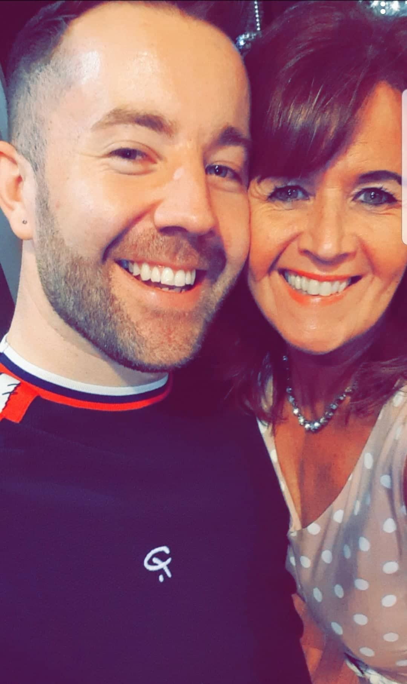
FAITHFUL SOUL
Choreographed by Gary O’Reilly & Maggie Gallagher (October 2019)
90 Count 2 Wall Intermediate Level Linedance
Music: Faith’s Song by Celtic Woman (album Ancient Land) (iTunes & Amazon)
Intro: 24 counts on vocals

S1: L FORWARD BASIC STEP, BACK, CROSS, BACK
1-2-3 Big step forward on left, Step right next to left, Step left in place next to right
4-5-6 Slightly angling body to 1:30 step back on right, Cross left over right, Step back on right [1:30]

S2: L BACK DRAG HOOK, CROSS, BACK, ¼
1-2-3 Big step back on left slightly angling body to 10:30, Drag right to meet left, Hook right in front of left [10:30]
4-5-6 Cross right over left, Step back on left straightening up to 12:00, ¼ right stepping right to right side [3:00]

S3: L TWINKLE, CROSS ¼ ½
1-2-3 Cross left over right, Step right to right side, Step left to left side
4-5-6 Cross right over left, ¼ right stepping back on left, ½ right stepping forward on right [12:00]

S4: WALK, SWEEP, R TWINKLE
1-2-3 Walk forward on left, Ronde sweep right from back to front over 2 counts
4-5-6 Cross right over left, Step left to left side, Step right to right side angling body to 1:30 [1:30]

S5: WALK, BRUSH, BRUSH, WALK, STEP ½ PIVOT
1-2-3 Walk forward on left, Brush right foot forward, Brush right foot across left
4-5-6 Walk forward on right, Step forward on left, ½ pivot right [7:30]

S6: WALK, BRUSH, BRUSH, CROSS, SIDE ROCK
1-2-3 Walk forward on left, Brush right foot forward, Brush right foot across left
4-5-6 Cross right over left, ⅛right rocking left to left side, Recover on right [9:00]

S7: CROSS, HOLD, HOLD, BACK, SIDE ROCK
1-2-3 Cross left over right, HOLD for two counts (right leg is stretched with toe pointed back)
4-5-6 Step back on right, Rock left to left side, Recover on right

S8: L TWINKLE, CROSS, SIDE, BEHIND
1-2-3 Cross left over right, Step right to right side, Step left to left side
4-5-6 Cross right over left, Step left to left side, Cross right behind left

S9: SIDE, POINT R, HOLD, ROLLING VINE
1-2-3 Big left step to left side, Point right to right side, HOLD looking left
4-5-6 ¼ right stepping forward on right, ½ right stepping back on left, ¼ right stepping right to right side

S10: SLOW ½ PIVOT R, CROSS SIDE ROCK
1-2-3 ⅛ right stepping forward on left [10:30], ½ pivot right keeping the weight back on left over 2 counts [4:30]
4-5-6 Cross right over left, Rock left to left side, Recover on right

S11: CROSS, POINT R, HOLD, CROSS, SIDE ROCK
1-2-3 Cross left over right, Point right to right side, HOLD [4:30]
4-5-6 Cross right over left, ⅛ right rocking left to left side, Recover on right [6:00]

S12: CROSS, HITCH BEHIND, BACK, SIDE ROCK
1-2-3 Cross left over right, Hitch right knee hooking right toe behind left, HOLD
4-5-6 Big step back on right, Rock left to left side, Recover on right

S13: BACK, SIDE ROCK, R COASTER
1-2-3 Big step back on left, Rock right to right side, Recover on left
4-5-6 Step back on right, Step left next to right, Step forward on right

S14: STEP, ½, TOGETHER, BACK, ½, TOGETHER
1-2-3 Step forward left, ½ left stepping back on right, Close left next to right [12:00]
4-5-6 Step back on right, ½ left stepping forward on left, Close right next to left [6:00] *Restart Wall 1

S15: STEP, TOUCH, HOLD, BACK, TOUCH, HOLD
1-2-3 Step forward on left, Touch right next to left, HOLD
    - Step back on right, Touch left next to right, HOLD Tag Wall 2

*RESTART: Wall 1 after 84 counts (drop last 6 counts of the dance) (facing 6:00)

TAG: After Wall 2 repeat last 6 counts of the dance (S15) (facing 12:00)

ENDING: Wall 6 dance the first 6 counts, ⅝ left stepping forward on the left, Sweep right over left

Contact:
Maggie Gallagher:
www.facebook.com/MaggieGChoreographer
www.maggieg.co.uk

Gary O’Reilly:
oreillygaryone@gmail.com 00353857819808
https://www.facebook.com/gary.reilly.104
www.thelifeoreillydance.com

Last Update – 22 Oct. 2019

