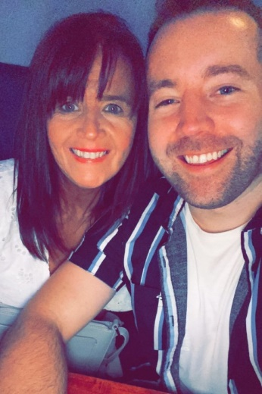
Hasta La Vista
Choreographed by Gary O’Reilly & Maggie Gallagher (June 2022)
48 Count, 2 Wall, Intermediate level line dance.
Choreographed to: “Hasta La Vista” by Alexandra Joner [2:56]
Available from iTunes & Amazon
16 count intro

Section 1: WALK, PRESS, & CROSS & CROSS & CROSS, UNWIND 1/2, 1/2 SIDE, TOUCH &
1 2 Walk forward on R (1), press forward on L opening body up to R diagonal (1:30) (2) (1:30)
& 3 Step back on ball of R (&), cross L over R (3)
& 4 Step back on ball of R (&), cross L over R (4)
& 5 Step back on ball of R (&), cross L over R (5) (3:00)
*counts 3-5 travel back along a diagonal gradually straightening up to (3:00)
6 7 Unwind ½ R transferring weight onto R (6), ½ R stepping L to L side (7) (3:00)
8 & Touch R next to L (8), step R next to L (&)

Section 2: CROSS, BACK BACK, CROSS, BACK & WALK, 1/4 HITCH, BUMP & BUMP/PUSH &
1 2 & Cross L over R (1), step back on R (2), step back on L on slight L diagonal (&)
3 4 & Cross R over L (3), step back on L (4), step R next to L (&)
5 6 Walk forward on L (5), ¼ L hitching R knee up and pushing R hip out to R (6) (12:00)
7&8& Step R to R side bumping hip to R (7), bump L (&), bump R pushing out to R (8), step on ball of L in place (&) *RESTART WALL 5

Section 3: CROSS, 1/4, BALL 1/4, BALL 1/4, BALL, 1/4, HOLD, TRIPLE FULL TURN
1 2 Cross R over L (1), ¼ L stepping forward on L (2) (9:00)
& 3 Step on ball of R next to L (&), ¼ L stepping forward on L (3) (6:00)
& 4 Step on ball of R next to L (&), ¼ L stepping forward on L (4) (3:00)
& 5 Step on ball of R next to L (&), ¼ L crossing over R (5) (12:00)
6 HOLD (6)
7 & 8 Triple full turn over R on the spot stepping RLR slightly crossing R over L on count 8 (7&8) (12:00)

Section 4: SIDE, CLOSE TOGETHER, SIDE, CLOSE TOGETHER, FWD ROCK, 1/2, ROCKING CHAIR
1 2 & Step L to L side (1), step R next to L (2), step L in place (&)
3 4 & Step R to R side (3), step L next to R (4), step R in place (&)
5 6 & Rock forward on L (5), recover on R (6), ½ L stepping forward on L (&) (6:00)
7&8& Rock forward on R (7), recover on L (&), rock back on R (8), recover on L (&)

Section 5: SIDE/DRAG, ROCK BACK SIDE, TOUCH BACK TOUCH, HOLD, BACK TOUCH BACK TOUCH
1 Long step R to R side dragging L to meet R (1)
2 & 3 Rock L behind R (2), recover on R (&), long step L to L side (3)
4 & 5 Touch R next to L (4), step back diagonally R on R (&), touch L next to R (5)
6 HOLD (6)
&7&8 Step back diagonally L on L (&), touch R next to L (7), step back diagonally R on R (&), touch L next to R (8)

Section 6: FLICK POINT, HOLD, & WALK R WALK L, OUT OUT, BACK, COASTER STEP
& 1 2 Flick L out to L side (&), point L forward with slight bend in L knee (weight remains on R) (1), HOLD (2)
& 3 4 Step on ball of L next to R (&), walk forward on R (3), walk forward on L (4)
& 5 6 Step forward and out on R (&), step L out to L side (5), walk back on R (6)
7 & 8 Step back on L (7), step R next to L (&), step forward on L (8)

*RESTART: Dance 16 counts of Wall 5 & restart the dance facing (12:00)

ENDING: Dance ends facing (6:00) after 48 counts of Wall 6, make a sharp ½ turn over R stepping forward on R to finish facing (12:00)

Contact:
Gary O’Reilly
oreillygaryone@gmail.com
00353857819808
https://www.facebook.com/gary.reilly.104
www.thelifeoreillydance.com

