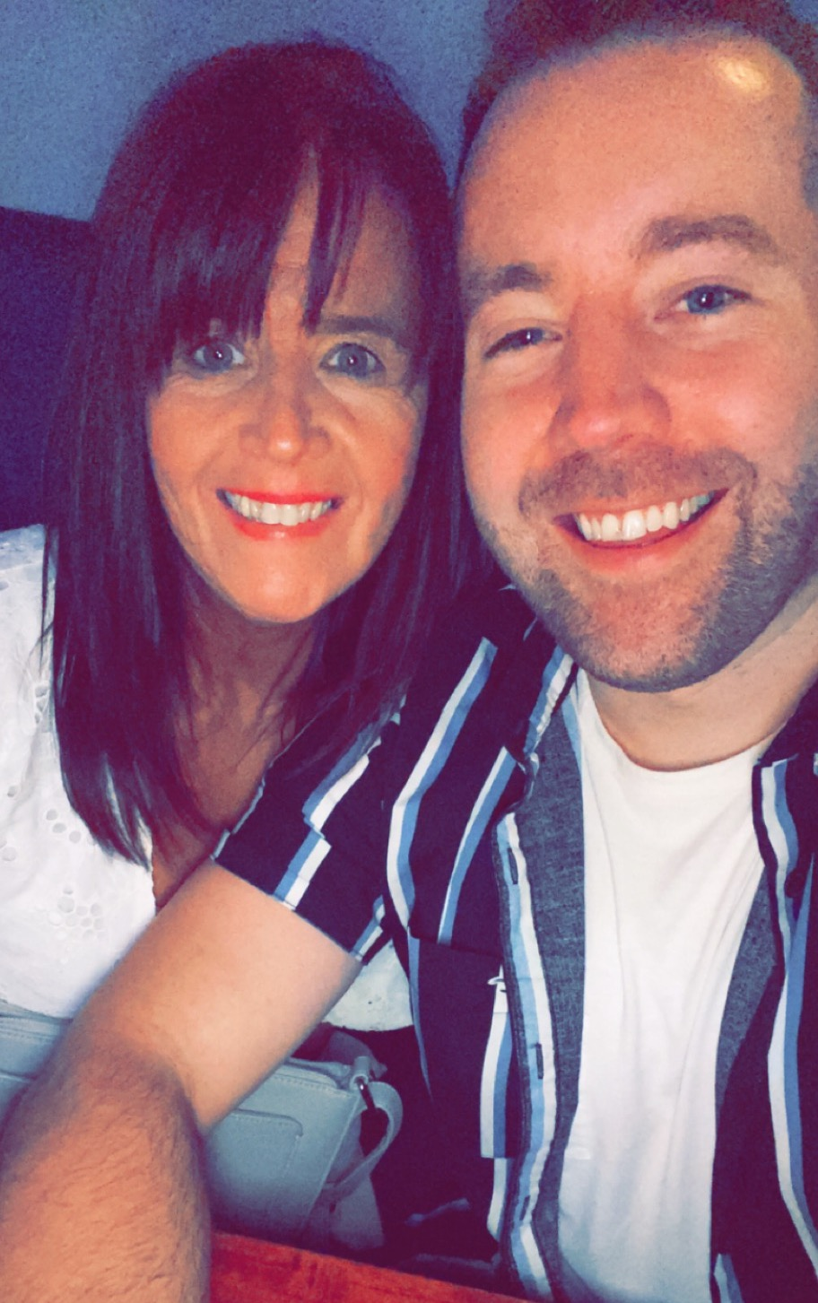
Here We Go
Choreographed by Gary O’Reilly & Maggie Gallagher (September 2021)
64 Count, 2 Wall, High Improver level line dance.
Choreographed to: “Here I Go” by Wildflowers (feat. Jason Dering) 3m50s
Available from iTunes & Amazon
32 count intro

Section 1: SIDE, TOGETHER, SHUFFLE FWD, FWD ROCK, CHASSE ¼
1 2 Step R to R side (1), step L next to R (2)
3 & 4 Step forward on R (3), step L next to R (&), step forward on R (4)
5 6 Rock forward on L (5), recover on R (6)
7 & 8 ¼ L stepping L to L side (7), step R next to L (&), step L to L side (8) (9:00)

Section 2: CROSS, SIDE, SAILOR STEP, CROSS, ¼, CHASSE ¼
1 2 Cross R over L (1), step L to L side (2)
3 & 4 Cross R behind L (3), step L to L side (&), step R to R side (4)
5 6 Cross L over R (5), ¼ L stepping back on R (6) (6:00)
7 & 8 ¼ L stepping L to L side (7), step R next to L (&), step L to L side (8) (3:00)

Section 3: CROSS, HOLD, & HEEL, HOLD, & CROSS, SIDE, SAILOR ¼
1 2 Cross R over L (1), HOLD (2)
& 3 4 Step back on L (&), dig R heel to R diagonal (3), HOLD (4)
& 5 6 Step R next to L (&), cross L over R (5), step R to R side (6)
7 & 8 Cross L behind R (7), ¼ L stepping R to R side (&), step forward on L (8) (12:00)

Section 4: STEP, PIVOT ¼, STEP, PIVOT ¼, JAZZBOX
1 2 Step forward on R (1), pivot ¼ L pushing hips out to R (2) (9:00)
3 4 Step forward on R (3), pivot ¼ L pushing hips out to R (4) (6:00)
5 6 Cross R over L (5), step back on L (6)
7 8 Step R to R side (7), step forward on L (8) **Restart Wall 6

Section 5: TOUCH & HEEL & HEEL, HOLD, & TOUCH & HEEL & HEEL, HOLD
1&2& Touch R toe next to L instep (1), step slightly back on R (&), dig L heel forward (2), step L next to R (&)
3 4 Dig R heel forward (3), HOLD (4)
&5&6 Step R next to L (&), touch L toe next to R instep (5), step slightly back on L (&), dig R heel forward (6)
& 7 8 Step R next to L (&), dig L heel forward (7), HOLD (8)

Section 6: & FWD ROCK, SHUFFLE ½, FWD ROCK, SHUFFLE ½
& 1 2 Step L next to R (&), rock forward on R (1), recover on L (2)
3 & 4 ¼ R stepping R to R side (3), step L next to R (&), ¼ R stepping forward on R (4) (12:00)
5 6 Rock forward on L (5), recover on R (6)
7 & 8 ¼ L stepping L to L side (7), step R next to L (&), ¼ L stepping forward on L (8) (6:00) **Restart Wall 5

Section 7: TOUCH & HEEL & HEEL, HOLD, & TOUCH & HEEL & HEEL, HOLD
1&2& Touch R toe next to L instep (1), step slightly back on R (&), dig L heel forward (2), step L next to R (&)
3 4 Dig R heel forward (3), HOLD (4)
&5&6 Step R next to L (&), touch L toe next to R instep (5), step slightly back on L (&), dig R heel forward (6)
& 7 8 Step R next to L (&), dig L heel forward (7), HOLD (8)

Section 8: & SIDE ROCK, BEHIND SIDE CROSS, SIDE ROCK, BEHIND SIDE CROSS
& 1 2 Step L next to R (&), rock R to R side (1), recover on L (2)
3 & 4 Cross R behind L (3), step L to L side (&), cross R over L (4)
5 6 Rock L to L side (5), recover on R (6)
7 & 8 Cross L behind R (7), step R to R side (&), cross L over R (8)

*TAG: At the end of Wall 1 facing (6:00), dance the 4 count Tag:
SIDE, TOUCH, SIDE, TOUCH
1 2 Step R to R side (1), touch L next to R (2)
3 4 Step L to L side (3), touch R next to L (4)

**RESTARTS: After 48 counts of Wall 5 facing (6:00) & after 32 counts of Wall 6 facing (12:00)

ENDING: Dance 64 counts of Wall 7, then unwind ½ R to finish the dance facing (12:00)

Contact: Gary O’Reilly:
oreillygaryone@gmail.com 00353857819808 https://www.facebook.com/gary.reilly.104 www.thelifeoreillydance.com
Maggie Gallagher: +447950291350
www.facebook.com/MaggieGChoreographer www.maggieg.co.uk

