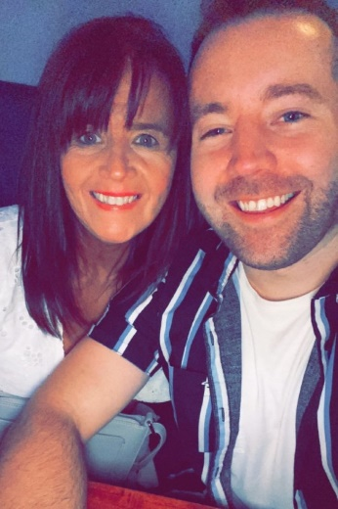
Hold Me Closer
Choreographed by Gary O’Reilly & Maggie Gallagher (August 2022)
64 Count, 2 Wall, Intermediate level line dance.
Choreographed to: “Hold Me Closer” by Elton John & Britney Spears (3m22s)
Available from iTunes, Amazon & Spotify
32 count intro

Section 1: WALK, KICK BACK TOUCH, LOCK STEP FORWARD, FWD ROCK, SHUFFLE 1/2
1 Walk forward on L (1)
2 & 3 Kick R forward (2), step back on R (&), touch L in front of R sitting into R hip with L knee bent (3)
4 & 5 Step forward on L (4), lock step R behind L (&), step forward on L (5)
6 7 Rock forward on R (6), recover on L (7)
8 & 1 ¼ R stepping R to R side (8), step L next to R (&), ¼ R stepping forward on R (1) (6:00)

Section 2: WALK, 1/4, SAILOR ½ CROSS, HOLD, & CROSS, CHASSE R
2 3 Walk forward on L (2), ¼ L stepping R to R side (3) (3:00)
4 & 5 Cross L behind R (4), ½ L stepping R in place next to L (&), cross L over R (5) (9:00)
6 & 7 HOLD (6), step R slightly to R side (&), cross L over R (7)
8 & 1 Step R to R side (8), step L next to R (&), step R to R side (1)

Section 3: ROCK, RECOVER, CHASSE L, HOLD, & 1/4, STEP, PIVOT 1/2 L
2 3 Rock L behind R popping R knee (2), recover on R popping L knee (3)
4 & 5 Step L to L side (4), step R next to L (&), step L to L side (5)
6 & 7 HOLD (6), step on ball of R next to L (&), ¼ L stepping step forward on L (7) (6:00)
8 1 Step forward on R (8), pivot ½ turn L (1) (12:00)

Section 4: WALK R, WALK L, ANCHOR STEP, BACK L, BACK R, L COASTER STEP
2 3 Walk forward on R (2), walk forward on L (3)
4 & 5 Lock R behind L (4), step weight onto L (&), step slightly back on R (5)
6 7 Walk back on L (6), walk back on R (7)
8 & 1 Step back on L (8), step R next to L (&), step forward on L (1) *Restart (Wall 3)

Section 5: TOE/BRUSH OUT OUT, HOLD, & CROSS, UNWIND ½, BACK/SIT, TOUCH
2 & 3 Brush ball of R toe next to L instep and swing R leg out to R side (2), step out R to R side (&), step out L to L side (weight on L) (3)
4 HOLD (4)
& 5 6 Step on ball of R next to L (&), cross L over R (5), unwind 1/2 turn R (weight ends on L) (6) (6:00)
7 8 Step back on R sitting into R hip (7), touch L next to R (8)

Section 6: CROSS SWEEP, CROSS SWEEP, CROSS, 1/4, COASTER STEP
1 2 Cross L over R (1), sweep R around from back to front (2)
3 4 Cross R over L (3), sweep L around from back to front (4)
5 6 Cross L over R (5), ¼ L stepping back on R (6) (3:00)
7 & 8 Step back on L (7), step R next to L (&), step forward on L (8)

Section 7: BUMP & BUMP, STEP, PIVOT 1/2, BUMP & BUMP, STEP, PIVOT 1/4
1 & 2 Step ball of R forward bumping R hip forward/up (1), bump/push back L hip (&), bump/push R forward transferring weight onto R (2)
3 4 Step forward on L (3), pivot ½ R (4) (9:00)
5 & 6 Step ball of L forward bumping L hip forward/up (5), bump/push back R hip (&), bump/push L forward transferring weight onto L (6)
7 8 Step forward on R (7), pivot ¼ L (8) (6:00)

Section 8: CROSS, POINT, BACK, SWEEP, SAILOR SIDE, HOLD, BALL STEP
1 2 Cross R over L (opening body to L diagonal) (1), point L to L side (2)
3 4 Step back on L slightly behind R (3), sweep R around from front to back (straighten up to back wall) (4)
5 & 6 Cross R behind L (5), step L to L side (&), step R to R side (6)
7 & 8 HOLD (7), step on ball of L next to R (&), step forward on R (8)

*Restart (Wall 3) – after 32 counts (facing 12:00)
The last step of the “L coaster step” is the beginning of (Wall 4)

ENDING: During Wall 7, dance up-to count 7 of section 4 and add the following to the end facing the front wall (12:00)
Touch L toe back, unwind 1/2 L taking weight onto L, Walk forward on R.

Contact: Gary O’Reilly - oreillygaryone@gmail.com - 00353857819808
https://www.facebook.com/gary.reilly.104 - www.thelifeoreillydance.com
Maggie Gallagher - +44 7950291350
www.facebook.com/maggiegchoreographer - www.maggieg.co.uk

