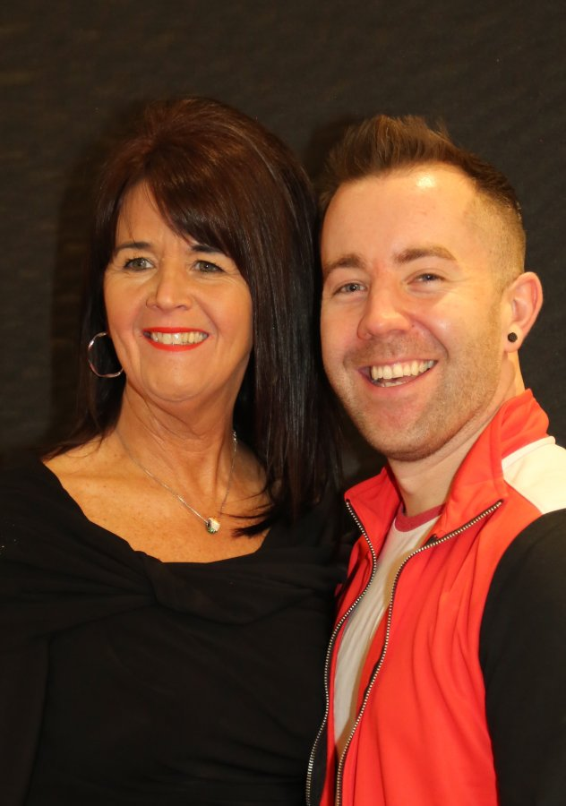
On The Other Side

Choreographed by Maggie Gallagher & Gary O’Reilly (May 2020)
32 Count, 2 Wall, Intermediate Line Dance
Choreographed to: “On The Other Side” by Nathan Carter
16 count intro
Choreographed especially for the “Celtic Duo Live Event”, in aid of Cancer Research & the LDF.

Section 1: CROSS ROCK SIDE, CROSS ¼ SIDE, TOUCH DRAG, BEHIND SIDE, CROSS ROCK
1&2 Cross rock R over L (1), Recover on L (&), Long step R to R side (2)
3&4 Cross L over R (3), ¼ L stepping back on R (&), Step L to L side (4) (9:00)
&5 Touch R next to L (&), Long step R to R side dragging L to meet right (5)
6&7-8 Cross L behind R (6), Step R to R side (&), Cross rock L over R (7), Recover on R (8)

Section 2: & CROSS & BEHIND, ¼, STEP, PIVOT ½, WALK, TRIPLE FULL TURN, MAMBO DRAG
&1&2 Step L to L side (&), Cross R over L (1), Step L to L side (&), Cross R behind L (2)
&3-4-5 ¼ turn L stepping forward on L (&), Step forward on R (3), Pivot ½ turn L (4), Walk forward on R (5) (12:00)
6&7 ½ R stepping back on left (6), ½ R stepping forward on R (&), Step forward on left (7) (12:00)
8&1 Rock forward on R (8), Recover on L (&), Long step back on R dragging L to meet right (1)

Section 3: BACK ¼ POINT, SWAY, SWAY, RUN RUN, WALK/SWEEP, WALK
2&3 Step back on L (2), ¼ R stepping R to R side (&), Point L to L side angling body to R diagonal (3) (3:00)
4-5 Sway L angling body to L diagonal (4), Sway R angling body to R diagonal (5)
6&7 ¼ L stepping forward on L (6), ¼ L stepping forward on R (&), ¼ L walking forward on L sweeping R to front (7) (6:00)
8 Walk forward on R (8) *Restart Wall 4

Section 4: ½, BACK/SWEEP, BACK/SWEEP, COASTER STEP, ½, BACK/SWEEP, BACK/SWEEP, COASTER CROSS &
&1-2 ½ R stepping back on L (&), Walk back on R sweeping L from front to back (1), Walk back on L sweeping R from
front to back (2) (12:00)
3&4& Step back on R (3), Step L next to R (&), Step forward on R (4), ½ R stepping back on L (&) (6:00)
5-6 Walk back on R sweeping L from front to back (5), Walk back on L sweeping R from front to back (6)
7&8& Step back on R (7), Step L next to R (&), Cross R over L (8), Step L to L diagonal (&)

*RESTART: After 24 counts of Wall 4 facing (12:00) add:
(&) Step L towards L diagonal, then restart dance from the beginning.

ENDING: Dance 8 counts of Wall 8, then slow down for 16 counts with the music and finish facing (12:00)

Contact: Maggie Gallagher - www.facebook.com/maggiegchoreographer - www.maggieg.co.uk
Gary O’Reilly - oreillygaryone@gmail.com - 00353857819808
https://www.facebook.com/gary.reilly.104 - www.thelifeoreillydance.com

