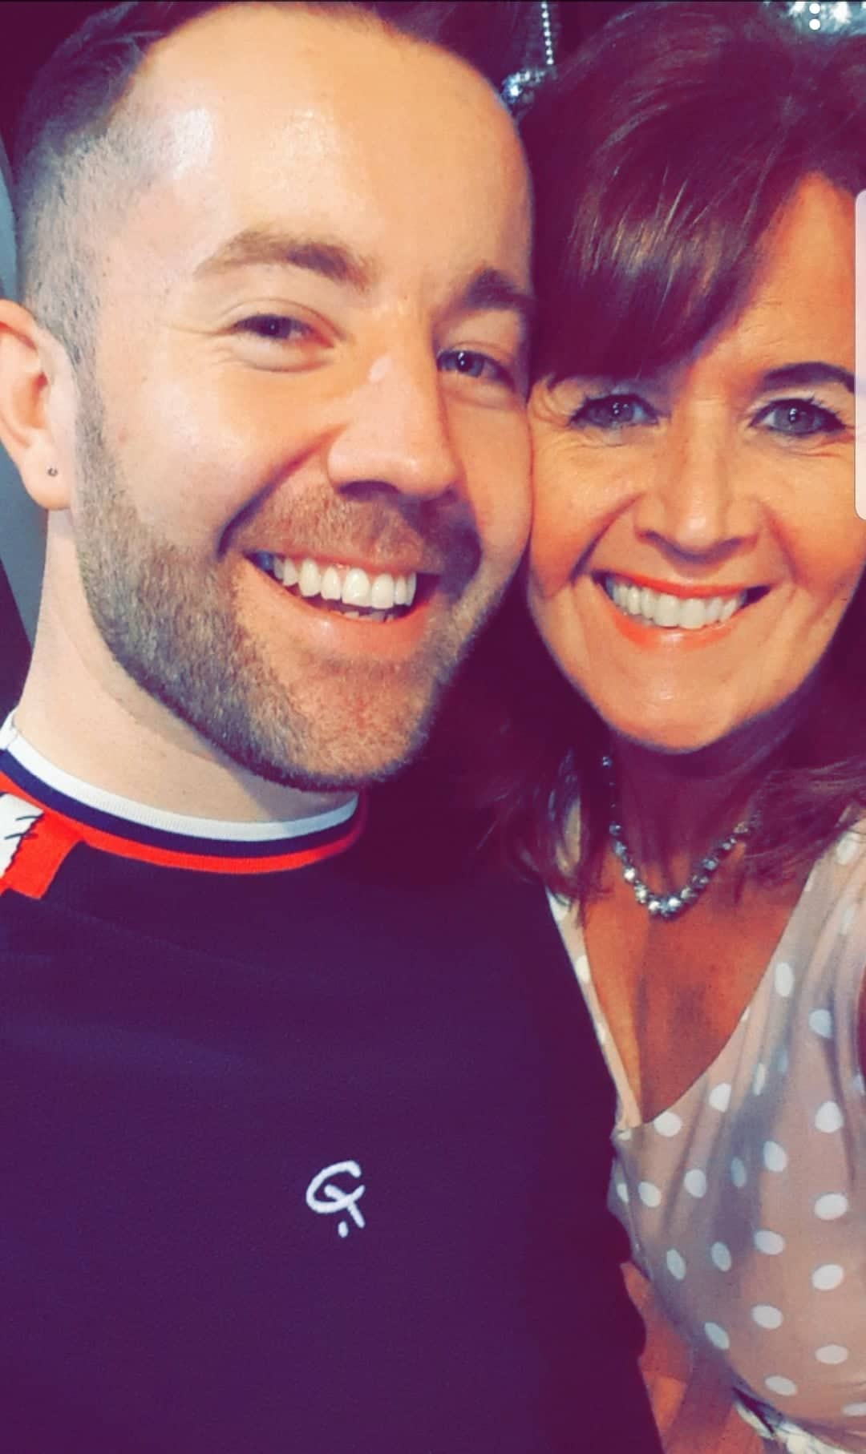
React
Choreographed by Maggie Gallagher & Gary O’Reilly (February 2020)
64 Count, 2 Wall Intermediate
Choreographed to: “React” by The Pussycat Dolls
16 count intro
No Tags/No Restarts

Thank you to Marc Jennings & Kelvin Deadman for suggesting this music to us both.

S1: WALK, FORWARD ROCK, LOCK STEP BACK, ¼, POINT, HOLD, & CROSS
1-2-3 Walk forward on L (1), push/rock forward on R (2), recover on L (3)
4&5 Step back on R (4), cross L over R (&), step back on R (5)
6-7-8 ¼ turn L stepping L to L side (6), point R to R side (7), HOLD (8) [9:00]
&1 Step R next to L (&), cross L over R (1)

S2: DIAGONAL ROCK, BEHIND SIDE CROSS, DIAGONAL ROCK, BEHIND SIDE FORWARD
2-3 Rock R to R side towards R diagonal (10:30) (2), recover on L (3)
4&5 Cross R behind L (4), step L to L side (&), cross R over L (5)
6-7 Rock L to L side towards to L diagonal (7:30) (6), recover on R (7)
8&1 Cross L behind R (8), step R to R side (&), step forward on L (1)

S3: HOLD, PIVOT ½, ½, FUNKY BACK TOUCHES R & L
2 HOLD (2)
3-4 Pivot ½ turn R (weight ends on R) (3), ½ turn R stepping slightly back on L (4) [9:00]
5-6 Step back on R opening body to R rolling R shoulder back (5), touch L next to R dipping into R hip (6)
7-8 Step back on L opening body to L rolling L shoulder back (7), touch R next to L dipping into L hip (8)

S4: OUT, OUT, IN, CROSS, & HEEL & TOUCH, OUT, OUT, HOLD, & WALK, ¼ HITCH
&1&2 Step R out to R side (&), step L out to L side (1), step R in next to L (&), cross L over R (2)
&3&4 Step R to R side (&), tap L heel to L (3), step L in place (&), touch R next to L (4)
&5-6 Step R out to R side (&), step L out to L side (5), HOLD (6)
&7-8 Step R in next to L (&), walk forward on L (7), ¼ turn L hitching R knee up (8) [6:00]

S5: SIDE, TORQUE/LOOK, ¼, ¼, BEHIND/POP, ¼, ¼, BEHIND
1-2 Step R to R side (1), torque upper body R looking to R with L pointed to L side (2)
3-4 ¼ turn L stepping slightly forward on L (3) ¼ turn L stepping R to R side (4) [12:00]
5-6 Cross L behind R *option: popping R knee (5), ¼ turn R stepping slightly forward on R (6) [3:00]
7-8 ¼ turn R stepping L to L side (7), cross R behind L (8) [6:00]

S6: SIDE, TORQUE/LOOK, ¼, ¼, BEHIND/POP, ¼, STEP, PIVOT ⅜
1-2 Step L to L side (1), torque upper body L looking to L with R pointed to R side (2)
3-4 ¼ turn R stepping slightly forward on R (3) ¼ turn R stepping L to L side (4) [12:00]
5-6 Cross R behind L *option: popping L knee (5), ¼ turn L stepping slightly forward on L (6) [9:00]
7-8 Step forward on R (7), pivot ⅜ turn L (8) [4:30]

S7: WALK R, WALK L, FORWARD COASTER, BACK, BACK, BACK/POP, FORWARD
1-2 Walk forward on R to diagonal (1), walk forward on L to diagonal (2)
3&4 Walk forward on R bending knees (3), step L next to R bending knees (&), step back on R (4)
5-6 Walk back on L (5), ⅛ turn R walking back on R straightening up to [6:00] (6)
7-8 Walk back on L popping R knee keeping R toe touching floor (7), step R in place (8)

S8: WALK L, STEP, PIVOT ½, ½TURNING LOCK STEP BACK, PUSH BACK, RECOVER, STEP LOCK
1-2-3 Walk forward on L (1), step forward on R (2), pivot ½ turn L (3) [12:00]
4&5 ¼ turn L stepping R to R side (4), lock step L over R (&), ¼ turn L stepping back on R (5) [6:00]
6-7 Push/Rock back on L (6), recover on R (7)
8& Step forward on L (8), lock R behind L (&)

Contact:
Gary O’Reilly
oreillygaryone@gmail.com
00353857819808
https://www.facebook.com/gary.reilly.104
www.thelifeoreillydance.com
Maggie Gallagher
www.facebook.com/maggiegchoreographer
www.maggieg.co.uk

