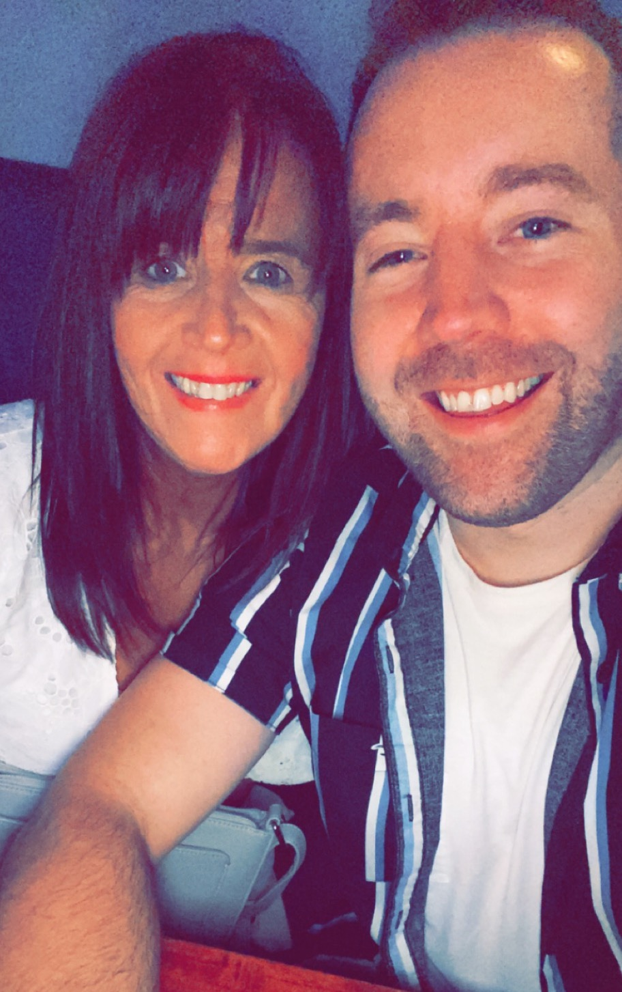
STARLIGHTS
Choreographed by Maggie Gallagher & Gary O’Reilly (October 2021)
64 Count 2 Wall Intermediate Level Linedance
Music: Starlight by Westlife (Amazon & iTunes)
Intro: 16 counts

S1: ROCK, RECOVER, ½ SHUFFLE R, ½ SHUFFLE R, ¼ SIDE ROCK
1-2 Rock forward on right, Recover on left
3&4 ¼ right stepping right to right side, Step left next to right, ¼ right stepping forward on right [6:00]
5&6 ¼ right stepping left to left side, Step right next to left, ¼ right stepping back on left [12:00]
7-8 ¼ right rocking right to right side, Recover on left [3:00]

S2: R SAILOR, TOUCH, ½ UNWIND, WALK, HOLD, & WALK, TOUCH
1&2 Cross right behind left, Step left to left side, Step slightly forward on right
3-4 Touch left behind right, Unwind ½ left (transferring weight to left) [9:00]
5-6 Walk forward on right, HOLD
&7-8 Step left next to right, Walk forward on right, Touch left behind right

S3: ½ PIVOT, HOLD, & WALK, TOUCH, POINT, HOLD, & POINT, HOLD
1-2 ½ pivot left stepping forward on left, HOLD [3:00]
&3-4 Step right next to left, Walk forward on left, Touch right next to left
5-6 Point right to right side, HOLD
&7-8 Step right next to left, Point left to left side, HOLD

S4: & SIDE ROCK, CROSS SHUFFLE, ¼, ¼, ¼, TOUCH
&1-2 Step left next to right, Rock right to right side, Recover on left
3&4 Cross right over left, Step left to left side, Cross right over left
5-6 ¼ right stepping back on left, ¼ right stepping forward on right [9:00]
7-8 ¼ right stepping left to left side, Touch right next to left [12:00]
* Restart Wall 2 **Tag & Restart Wall 7

S5: KICK & DIP/TOUCH, KICK & DIP/TOUCH, OUT, OUT, BACK, HITCH
1&2 Kick right forward, Step right next to left, Touch left next to right bending knees
3&4 Kick left forward, Step left next to right, Touch right next to left bending knees
5-6 Step right forward on right diagonal, Step left forward on left diagonal
7-8 Step back on right opening body to right diagonal, Hitch left knee across right while looking back
over right shoulder sitting into right hip

S6: WALK, ½, ROCK BACK, RECOVER, ½, ¼, CROSS, SWEEP
1-2 Walk forward on left, ½ left stepping back on right [6:00]
3-4 Rock back on left, Recover on right
5-6 ½ right stepping back on left, ¼ right stepping right to right side [3:00]
7-8 Cross left over right, Ronde sweep right around from back to front

S7: CROSS, SIDE, BEHIND, SWEEP, BEHIND, SIDE, CROSS, HITCH
1-2 Cross right over left, Step left to left side
3-4 Cross right behind left, Ronde sweep left from front to back
5-6 Cross left behind right, Step right to right side
7-8 Cross left over right, Ronde hitch right across left

S8: CROSS, ¼, CHASSE, CROSS ROCK, CHASSE
1-2 Cross right over left, ¼ right stepping back on left [6:00]
3&4 Step right to right side, Step left next to right, Step right to right side
5-6 Cross rock left over right, Recover on right
7&8 Step left to left side, Step right next to left, Step left to left side

*RESTART: After 32 counts of Wall 2 facing [6:00]

** TAG & RESTART: After 32 counts of Wall 7, dance the 4 count Tag:
1-2 Step right to right side, Touch left next to right
3-4 Step left to left side, Touch right next to left

Then restart the dance from the beginning facing [6:00]

ENDING: Dance ends facing the front [12:00] wall after count 64 of wall 8,
Adding: Step right to right side, taking both arms out to sides with palms open raising them up to the “Starlights”

Contact: Gary O’Reilly - oreillygaryone@gmail.com - 00353857819808
https://www.facebook.com/gary.reilly.104 - www.thelifeoreillydance.com
Maggie Gallagher - 0044 7950291350
www.facebook.com/maggiegchoreographer - www.maggieg.co.uk

