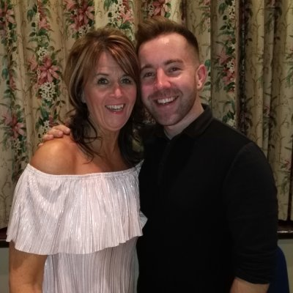
TENSION
Choreographed by Gary O’Reilly & Maggie Gallagher (October 2017)
64 Count 2 Wall Advanced Level Linedance
Music: Tension by Fergie (Amazon)
Intro: 16 counts (8 secs)

S1: WALK, PRESS, RECOVER/SWEEP, BEHIND SIDE SWAY, SWAY, SWAY & CROSS, ⅛, TOGETHER
1-2-3 Walk forward on right, Press forward on left, Recover on right ronde sweeping left around from front to back
4&5 Step left behind right, Step right to right side, Sway left stepping left to left side
6-7& Sway right, Sway left, Step right next to left
8&1 Cross left over right, ⅛ left stepping slightly back on right, Step left next to right [10:30]

S2: WALK, WALK, FWD MAMBO, ½, ⅞, L CHASSE
2-3 Walk forward on right, Walk forward on left
4&5 Rock forward on right, Recover on left, Step right next to left
6-7 ½ left stepping forward on left, ⅞ pencil turn over left shoulder (weight on right) [6:00]
8&1 Step left to left side, Step right next to left, Step left to left side

S3: CROSS ROCK, R CHASSE, CROSS, SIDE, SAILOR ½ CROSS
2-3 Cross rock right over left, Recover on left
4&5 Step right to right side, Step left next to right, Step right to right side
6-7 Cross left over right, Step right to right side
8&1 Cross left behind right, ½ left stepping right to right side, Cross left over right [12:00]

S4: HOLD, ⅛ BEHIND, HOLD, ⅛ CROSS, ⅛ BEHIND, ⅛ CROSS ⅛ TOGETHER
2&3-4 HOLD, ⅛ left stepping right to right side, Cross left behind right, HOLD [10:30]
&5&6 ⅛ left stepping right to right side, Cross left over right, ⅛ left stepping right to right side, Cross left behind right [7:30]
&7&8 ⅛ left stepping right to right side, Cross left over right, ⅛ left stepping right to right side, Step left next to right [4:30]

S5: WALK, WALK, ANCHOR STEP, ⅛ BACK, REVERSE ANCHOR STEP, WALK
1-2 Walk forward on right, Walk forward on left
3&4 Lock right behind left, Step weight onto left, Step slightly back on right
5- ⅛ left stepping back on left, [3:00]
6&7 Cross right over left, Step weight on left, Step forward on right
8 Walk forward on left

S6: POINT, HOLD, & POINT & CROSS, BACK, SIDE, CROSS SHUFFLE
1-2& Point right to right side, HOLD, Step right next to left
3&4 Point left to left side, Step left next to right, Cross right over left
5-6 Step back on left pushing hips back, Step right to right side
7&8 Cross left over right, Step right to right side, Cross left over right

S7: ‘C’ BUMP UP & DOWN, ¼, ½, ¼ ‘C’ BUMP UP & DOWN, ¼, ¼ POINT
1&2 Touch right to right side bumping hips up, Bump hips down to left, Step down on right bumping hips right
3-4 ¼ left stepping forward on left, ½ left stepping back on right [6:00]
5&6 ¼ left touching left to left side bumping hips up, Bump hips down to right, Step down on left bumping hips left [3:00]
7-8 ¼ right stepping forward on right, ¼ right pointing left to left side [9:00]

S8: CROSS, BACK & STEP LOCK &, ROCK, RECOVER, DRAG, BACK TOGETHER
1-2& Cross left over right, ¼ left stepping back on right, Step left slightly to left side [6:00]
3-4& Step forward on right, Lock left behind right, Step forward on right
5-6 Rock forward on left, Recover on right
7-8& Long step back on left dragging right to left, Step back on right, Step left next to right

www.maggieg.co.uk or www.facebook.com/MaggieGChoreographer

oreillygaryone@gmail.com or https://www.facebook.com/gary.reilly.104

