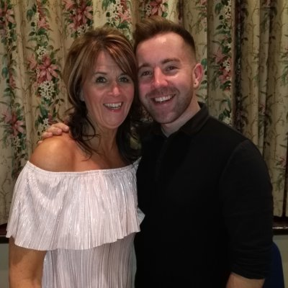
WHAT I MISS MOST
Choreographed by Maggie Gallagher & Gary O’Reilly (March 2018)
64 Count 4 Wall Intermediate Level Linedance
Music: What I Miss Most by Calum Scott (iTunes & Amazon 99p)
Intro: 16 counts

S1: BACK, SWEEP, BEHIND, SIDE, CROSS ROCK, SIDE ROCK
1-2 Step back on right, Sweep left from front to back
3-4 Step left behind right, Step right to right side
5-6 Cross rock left over right, Recover on right
7-8 Rock left to left side, Recover on right

S2: BACK, SWEEP, BEHIND, SIDE, CROSS ROCK, SIDE ROCK
1-2 Step back on left, Sweep right from front to back
3-4 Step right behind left, Step left to left side
5-6 Cross rock right over left, Recover on left
7-8 Rock right to right side, Recover on left

S3: STEP, HOLD & ROCK FORWARD, BACK, ½, STEP, ¼
1-2& Step forward on right, HOLD, Step left next to right
3-4 Rock forward on right, Recover on left
5-6 Walk back on right, ½ left stepping forward on left [6:00]
7-8 Step forward on right, ¼ pivot left stepping left to left side [3:00]

S4: DIAGONAL ROCK, R LOCK STEP, DIAGONAL ROCK, L LOCK STEP
1-2 Cross rock right over left, Recover on left
3&4 Step right forward, Lock left behind right, Step right forward
(Counts 1-4 travelling slightly on left diagonal)
5-6 Cross rock left over right, Recover on right
7&8 Step left forward, Lock right behind left, Step left forward
(Counts 5-8 travelling slightly on right diagonal) *RESTART Walls 3 & 6
(Audrey Watson “Be Strong” step)

S5: SIDE, TOUCH & SIDE ROCK, CROSS, SIDE, CROSS, HITCH
1-2& Step right to right side, Touch left next to right, Step left next to right
3-4 Rock right to right side, Recover on left
5-8 Cross right over left, Step left to left side, Cross right over left, Ronde hitch left from back to front

S6: CROSS, SIDE, CROSS, HITCH, CROSS, POINT & POINT, HITCH
1-4 Cross left over right, Step right to right side, Cross left over right, Ronde hitch right from back to front
5-6&7 Cross right over left, Point left to left side, Step left next to right, Point right to right side
8 Hitch right

S7: R CHASSE, BACK ROCK, SIDE, BEHIND, ¼, STEP
1&2 Step right to right side, Step left next to right, Step right to right side
3-4 Cross rock left behind right, Recover on right
5-6 Step left to left side, Step right behind left
7-8 ¼ left stepping forward on left, Step forward on right [12:00]

S8: ½, ¼, BEHIND, SIDE, ROCK FORWARD, OUT OUT, BACK
1-2 ½ pivot left stepping forward on left, ¼ left stepping right to right side [3:00]
3-4 Step left behind right, Step right to right side
5-6 Rock forward on left, Recover on right
&7-8 Small jump out left to left side, Small jump out right to right side, Step back on left

*RESTARTS: After 32 counts on Wall 3 facing [9:00] & Wall 6 facing [6:00]

ENDING: On Wall 9 after count 32, keep weight on left and turn ¼ left stepping forward on right [12:00]

THIS DANCE IS DEDICATED TO THE MEMORY OF A GOOD FRIEND
AUDREY WATSON

www.facebook.com/MaggieGChoreographer or www.maggieg.co.uk

https://www.facebook.com/gary.reilly.104 or email oreillygaryone@gmail.com

